1994-97 Honda Accord LX 4 door pin out
B1 | Black/White | Ceiling Light
B2 | Green/White | Passager Rear Door indicator
B3 | Green/Red | Passager Door indicator
B4 | Orange | Trunk Indicator
B5 | Green/Orange | Driver Door Indicator
B6 | Yellow | (+) No.1 (10A) fuse (Low Oil)
B7 | Red | Dash Light Dimmer
B8 | Red/Black | Combination Light Switch
B9 | Yellow/Green | Engine Coolant Temp.
B10 | Black | Ground
B11 | (BLANK) | (BLANK)
B12 | Blue | Tachometer
B13 | White/Green | Brake Light Indicator
B14 | Green/Yellow | Driver Rear Door Indicator
B15 | (BLANK) | (BLANK)
B16 | (BLANK) | (BLANK)
B17 | (BLANK) | (BLANK)
B18 | Yellow | (+) No.35 (15A) fuse (Hazard)
B19 | Yellow/Red | Low oil
B20 | White/Blue | Alternator
B21 | Blue/White | Hazard warning switch
B22 | Black/Yellow | (+) No.4 (7.5A) fuse (Charging)

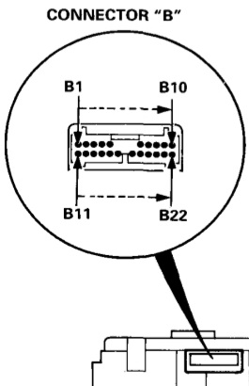

A1 | Blue/Red | (+) No.9 (7.5A) fuse (Brake Check)
A2 | Orange/White | Dimmer Relay (High Beam)
A3 | Red/Yellow | (+) No.19 (20A) fuse (High Beam Indicator)
A4 | Light Green/Red | MIL
A5 | Yellow | (+) No.1 (10A) fuse (MIL)
A6 | (BLANK) | (BLANK)
A7 | Green/Blue | Turn Signal Left
A8 | Green/Red | Brake Check + Brake System
A9 | Black | Ground (Turn Signal)
A10 | Red/Blue | Seat Belt
A11 | Green/Yellow | Turn Signal Right
A12 | Blue | SRS
A13 | (BLANK) | (BLANK)
A14 | (BLANK) | (BLANK)

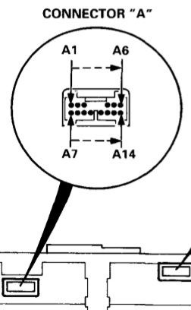
C1 | Yellow/Blue | Fuel
C2 | Light Green/Red | Low Fuel
C3 | Blue/Red | “D4"
C4 | (BLANK) | (BLANK)
C5 | Green/White | “P"
C6 | Green/Red | “R"
C7 | Green | “N"
C8 | (BLANK) | (BLANK)
C9 | Blue/White | ABS
C10 | (BLANK) | (BLANK)
C11 | Blue/Black | Cruise
C12 | Orange | Speedometer
C13 | Light Green/White | “1”
C14 | Green/Yellow | “2”
C15 | Light Green | ECM/TCM
C16 | Green/Blue | “D3"
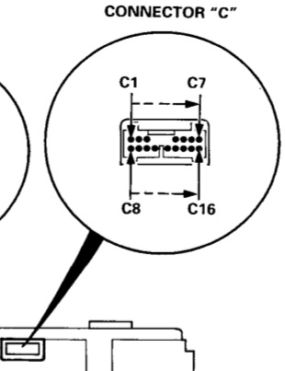

1998-99 Accord LX 4 Door
B1 | Blue | Tachometer
B2 | Blue/White | Speedometer
B3 | (BLANK) | (BLANK)
B4 | Red/White | Dash Light Dimmer
B5 | White/Red | Dash Light Dimmer
B6 | Green/Orange | MIL
B7 | Yellow/Red | Low Oil
B8 | White/Blue | Alternator
B9 | Black/Yellow | (+) No.6 (15A) fuse (Charging)
B10 | Red | Cluster Lights
B11 | Yellow | (+) No.9 (7.5A) fuse (Brake System)
B12 | (BLANK) | (BLANK)
B13 | (BLANK) | (BLANK)
B14 | (BLANK) | (BLANK)
B15 | (BLANK) | (BLANK)
B16 | Black | Ground
B17 | (BLANK) | (BLANK)
B18 | (BLANK) | (BLANK)
B19 | Pink | ECM/PCM (immobilizer)
B20 | White/Yellow | (+) No.13 (7.5A) fuse (Immobilizer)
B21 | White/Yellow | (+) No.13 (7.5A) fuse (Trip)
B22 | Red/Black | Combination Light Switch

A1 | Green/Yellow | Left Rear Door
A2 | Green/Orange | Driver Door
A3 | (BLANK) | (BLANK)
A4 | (BLANK) | (BLANK)
A5 | (BLANK) | (BLANK)
A6 | Blue/Black | Cruise
A7 | Green | Passager Door
A8 | Green/White | Right Rear Door
A9 | Orange | Trunk
A10 | Black/White | Ceiling Light
A11 | White/Green | Brake Light
A12 | Orange/White | High Beam Indicator
A13 | Red/Yellow | (+) No.45 (20A) fuse (High Beam)
A14 | Green/Blue | Left Turn Signal

C1 | Light Green/Red | Low Fuel
C2 | Yellow/Green | Coolant Temp
C3 | Red/Blue | Seat Belt
C4 | White | “R"
C5 | Brown | “1”
C6 | Pink | “D3"
C7 | Blue | “2”
C8 | Green/Yellow | Right Turn Signal
C9 | Blue | SRS
C10 | Blue/White | ABS
C11 | Yellow/Blue | Fuel
C12 | Green/Black | “D4"
C13 | (BLANK) | (BLANK)
C14 | Green/Red | Brake System Light
C15 | Black/Blue | “P"
C16 | Red/Black | “N"

Plug pin on 98-99 | Plug pin from 94-97 | Color
B1 | B12 | Blue | Tachometer
B2 | C12 | Orange | Speedometer
B3 | N/A | N/A | N/A
B4 | N/A | N/A | N/A
B5 | N/A | N/A | N/A
B6 | A4 | Light Green/ Red | MIL
B7 | B19 | Yellow/Red | Low Oil
B8 | B20 | White/Blue | Alternator
B9 | B22 | Black/Yellow | (+) No.4 (7.5A) fuse (Charging)
B10 | B7 | Red | Cluster Lights
B11 | B6 | Yellow | (+) No.1 (10A) fuse (Low Oil)
B12 | N/A | N/A | N/A
B13 | N/A | N/A | N/A
B14 | N/A | N/A | N/A
B15 | N/A | N/A | N/A
B16 | B10 | Black | Ground
B17 | N/A | N/A | N/A
B18 | N/A | N/A | N/A
B19 | N/A | N/A | N/A
B20 | N/A | N/A | N/A
B21 | A5 | Yellow | (+) No.1 (10A) fuse (MIL)
B22 | B8 | Red/Black | Combination Light Switch
1994-97 to 1998-99 cluster swap

Plug pin on 98-99 | Plug pin from 94-97 | Color
A1 | B14 | Green/Yellow | Left Rear Door
A2 | B5 | Green/Orange | Driver Door
A3 | N/A | N/A | N/A
A4 | N/A | N/A | N/A
A5 | N/A | N/A | N/A
A6 | C11 | Blue/Black | Cruise
A7 | B3 | Green/Red | Passager Door
A8 | B2 | Green/White | Right Rear Door
A9 | B4 | Orange | Trunk
A10 | B1 | Black/White | Ceiling Light
A11 | N/A | N/A | N/A
A12 | A2 | Orange/White | High Beam Indicator
A13 | A3 | Red/Yellow | (+) No.19 (20A) fuse (High Beam Indicator)
A14 | A7 | Green/Blue | Left Turn Signal

Plug pin on 98-99 | Plug pin from 94-97 | Color
C1 | C2 | Light Green/Red | Low Fuel
C2 | B9 | Yellow/Green | Coolant Temp
C3 | A10 | Red/Blue | Seat Belt
C4 | C6 | Green/Red | “R"
C5 | C13 | Light Green/White | “1”
C6 | C16 | Green/Blue | “D3"
C7 | C14 | Green/Yellow | “2”
C8 | A11 | Green/Yellow | Right Turn Signal
C9 | A12 | Blue | SRS
C10 | C9 | Blue/White | ABS
C11 | C1 | Yellow/Blue | Fuel
C12 | C3 | Blue/Red | “D4"
C13 | N/A | N/A | N/A
C14 | A8 | Green/Red | Brake Check + Brake System
C15 | C5 | Green/White | “P"
C16 | C7 | Green | “N"

